**Component Diagram**

The purpose of a component diagram is to show the relationship between different components in a system. Component diagrams are often Component diagrams are often drawn to help model implementation details and double-check that every aspect of the system's required functions is covered by planned development.

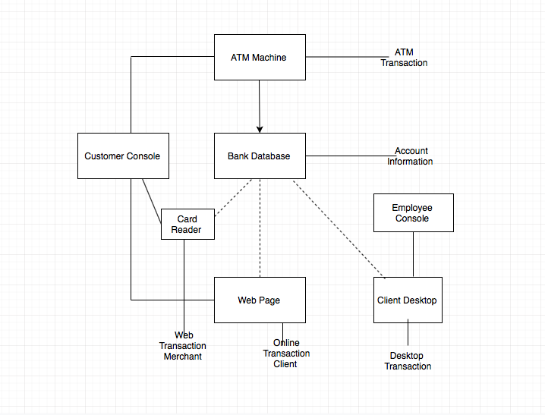

**Object Diagram**

An object diagram focuses on the attributes of a set of objects and how those objects relate to each other. For instance, in this object diagram below, all three attributes are tie to each other. The class titles show the type of departments within this particular bank. The class attributes are different for department. Object diagrams are simple to create: they're made from objects, represented by rectangles, linked together with lines. The use of object diagrams is fairly limited, namely to show examples of data structure.

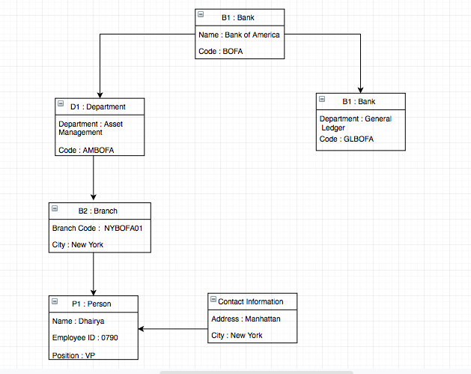

**Deployment Diagram**

The deployment diagram shows the execution architecture of a system, including nodes such as hardware or software execution environments and the middleware connecting them. Deployment diagrams can also be created to  explore the architecture of embedded showing how the hardware and software components work together. In order to create a model , Determine how to model the deployment architecture of a system. Identify the scope of the model and consider the fundamental technical issues along with identifying the nodes and their connections.

